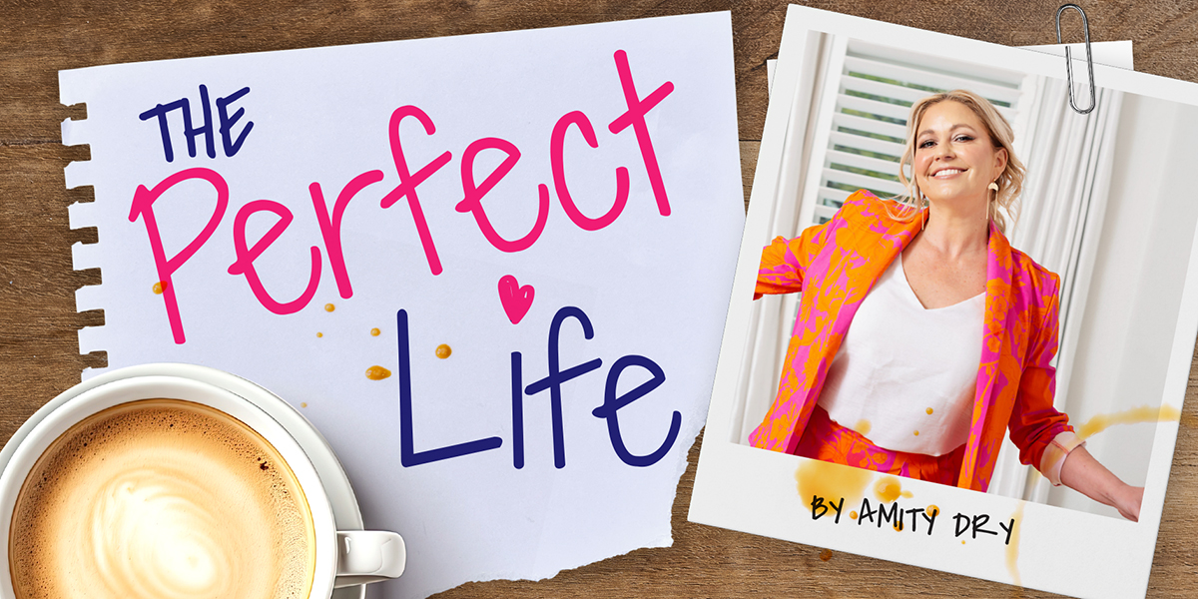

MEDIA RELEASE:

AMITY DRY BRINGS HER ORIGINAL MUSICAL HOME TO ADELAIDE FRINGE

Singer-songwriter, performer, and familiar South Australian face Amity Dry is returning to the stage with unfinished business, with a musical she first brought to life at the Adelaide Fringe nearly two decades ago.

THE PERFECT LIFE, an original Australian musical created by Dry, returns to the Adelaide Fringe in 2026 after an extraordinary journey that has taken it from Adelaide to New York, London, Norway and Finland, before coming home.

The musical explores the messy realities of modern womanhood with humour and honesty and stars the standout a cast including Helpmann Award winner Kerrie Anne Greenland (Miss Saigon, Les Misérables), Chloe Zuel (Hamilton, Six) and Dee Farnell (Urinetown).

First presented at the Adelaide Fringe in 2009 under the title Mother, Wife & the Complicated Life, the show quickly struck a chord with audiences. It grew into a full-length musical, touring regionally across South Australia, performing off-Broadway at the New York Musical Theatre Festival, appearing at the United Nations Commission for the Status of Women, and playing a four-week mainstage season in Norway. A later West End workshop at Wyndham’s Theatre positioned the show for further international development.

Then the world shut down.

As theatres closed and projects stalled during Covid, Dry, known to many South Australians for her top 10 album The Lighthouse, her appearances on The Block, and more recently her success in real estate, stepped away from the stage to focus on family and work, unsure if the musical would ever return.

“Like so many artists, I had to put the dream on hold,” Dry says. “But I never stopped believing in this show or the stories it tells. Life kept moving, and in many ways that made the work richer.”

Now, more than ten years after its last Australian season, The Perfect Life returns shaped by lived experience. The baby Dry was carrying while writing the musical is now 15. The themes of ambition, exhaustion, love, loss, friendship, and identity feel sharper, funnier, and more relevant than ever.

The show tackles subjects including pregnancy, marriage, divorce, post-natal depression, cancer and female friendship, balancing laughter with moments of raw emotional honesty. At its heart, it is a celebration of women navigating life as it really is, imperfect, contradictory and deeply human.

For Dry, the return is both personal and symbolic.

“Adelaide is where this show began,” she says. “Bringing it back to the Fringe feels like closing a circle and opening a new chapter.”

CRITICAL PRAISE (selected)

“This is the start of something big for this witty musical comedy… slick and snappy, with witty lyrics and belly laughs aplenty.” ArtsHub ★★★★½

“A genuinely warm and witty show… how wonderful to be able to say that it’s entirely Australian.” Stage Whispers

“A home-grown gem… funny, endearing and deeply relatable.” Theatre People ★★★★

“Dry bravely includes serious emotional moments… the risk pays off with a deeper, more involving show.” Man in Chair

“A home grown gem.” Adelaide Theatre Guide

SHOW DATES
Dates - March 12-21
Venue - 53 The Arts Theatre, Angas St Adelaide
Tickets - https://adelaidefringe.com.au/fringetix/the-perfect-life-af2026

CAST/CREATIVE TEAM
Produced by Popjam Productions
Director - Jo Casson
Musical Director – Martin Cheney
Cast – Kerrie Anne Greenland, Chloe Zuel, Dee Farnell & Amity Dry

MEDIA / BOOKINGS
Amity Dry – 0438144224 – amity@theperfectlifemusical.com
Nikki Earl – 0422480 520 - events@nikkiearl.com

www.theperfectlifemusical.com

